Mr. and Mrs. ___________
218 Oak Grove Ave.
Sawyer, MI 49125-8346

Dear Friends and Family,
In November of 2010, Covenant Point Bible Camp's beloved camp director, Charles "Chuck" Frasier, passed away unexpectedly. This past summer, Covenant Point faithfully began moving in their "Next Step of Faith" and began the Chuck Frasier Memorial Campaign. Through this campaign, CPBC’s $600,000 goal will build a new executive director's home as well as endow the current CPBC Internship Program. With God’s guidance and the generous support of this camp community, CPBC currently has $445,000 pledged to this campaign!

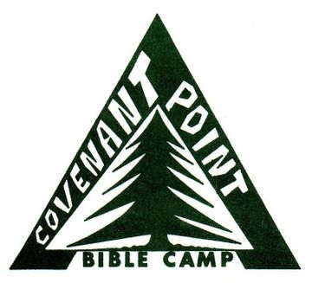
Because of the impact Covenant Point has had on my life, or the lives of loved ones, I am excited to share that my next step is to JOIN Covenant Point in helping complete the final leg of the Chuck Frasier Memorial Campaign. I have registered to (RUN/WALK) in the Chicago (5K/Half-Marathon) on Sunday, September 9, 2012 and have pledged to raise ($1250) to donate to the campaign.
OUR NEXT STEP OF FAITH

The Chuck Frasier Memorial Campaign

OUR NEXT STEP OF FAITH

The Chuck Frasier Memorial Campaign

Owned and operated by the Central Conference of the Evangelical Covenant Church
358 W. Hagerman Lake Road, Iron River, MI 49935 | Phone: 906.265.2117
Fax: 906.265.5123 | Email: cpbc@cpbc.com | www.cpbc.com
Today, I am asking you to consider supporting me as I take part in this unique opportunity. If you feel led to make a donation to this cause that is close to my heart, please make checks payable to Covenant Point Bible Camp (memo line: Chuck Frasier Memorial Campaign), or donate online at cpbc.com/campaign (include my name). Your support is greatly appreciated!
Please keep me in your prayers as I begin this challenge and continue praying for the ministry of Covenant Point.

God Bless,
Name

