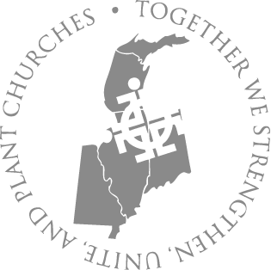
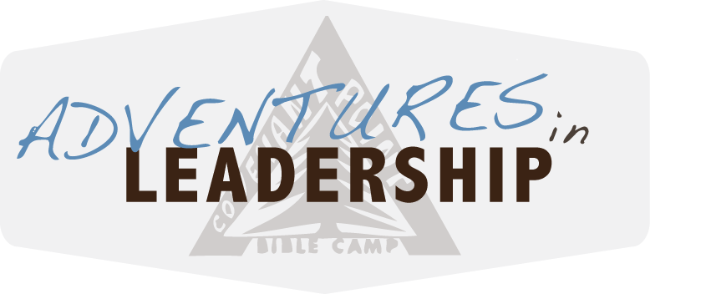

Dear Adventures in Leadership 2018 student:

Hello from Covenant Point! We are very excited about Adventures in Leadership. We have several youth leader representatives from the Central Conference joining us, as well as Covenant Point staff and trip guides. Adventures in Leadership runs from 4:00 PM (Central Time) Sunday, June 24th through 9:00 AM (Central Time) Saturday, June 30th. If riding the bus to/from Chicago, Elgin, Rockford, or Madison, please be familiar with drop off and pickup times (www.cpbc.com/bus).

Our first two nights will be spent “in base” at camp, sleeping in rustic yurts in our back 40. The next three nights and four days, we will spend backpacking and camping along Pictured Rocks National Lakeshore on Lake Superior, followed by a day of kayak training and a guided kayak trip on Lake Superior. Each day we take the time to prepare our meals, hike to our next campsite, enjoy individual quiet time, play group games and learn leadership skills together.

As with any trip there is a certain amount of risk involved. To reduce risk and respond to any emergency we will be carrying a cell phone as well as a detailed itinerary with contact phone numbers of local authorities and emergency response teams. Your Covenant Point Trip Guides are all CPR and Wilderness First Aid trained, as well as certified lifeguards. We will always carry appropriate medical supplies. Please contact camp if you have any questions or concerns.

On the back of this letter you will find a packing list for your time at camp and on trail. Make sure both you and your parents look over it as soon as you can, and double check it before you leave for the trip. Also, please be sure you are paid in full before the trip. We are encouraging students to communicate with their church about this opportunity and are encouraging churches to contribute half ($175). As a participant in this program, it is your responsibility to communicate with your church about this opportunity.

We look forward to seeing you soon!


Dustin Johnson,
Program Manager, Covenant Point Bible Camp

AIL 2018 (Backpacking) Packing List

Covenant Point will provide tents, sleeping pads, backpacks, cooking equipment, water bottles, plates/bowls, utensils, and food. If you would like to bring any of your own equipment listed above, you may, but it must be cleared with our guides before the trip.

The following items are recommended:
- completed health form with food allergy/restrictions/info (if we don’t have it already)
- required medications (will be checked in with our staff)
- mummy style sleeping bag with stuff sack: must be warm, lightweight and packable (4-5 pounds max., fit into stuff sack 10X20 max., min. 20 degree F rating)
- fitted sheet and pillow for your stay at camp (will not go on trail)
- slippers/moccasins for inside the yurt (optional)
- hard-soled ankle-high hiking boots (well broken in before the trip)
- water shoes or sandals
- tennis shoes for running around at camp
- dry comfortable shoes to change into at campsites – to get out of your hiking boots.
- several changes of clothes: prepare for hot and cold weather, shorts and jeans for stay at camp, long-underwear or leggings, sweatpants for sleeping (layers work best - synthetic or wool provides warmth when wet)
- wool socks (2 pair)
- hat and mittens/gloves (fleece or wool)
- warm fleece, synthetic, or wool sweatshirt or sweater
- raincoat / waterproof pants
- tee shirts (2 for trip, several for camp)
- loose fitting pants that can get wet (not jeans)
- shorts (one pair for trip, several for at camp)
- modest swimsuit (for trip and at camp)
- sunglasses, brimmed hat, sunscreen, lip balm
- small non-aerosol bug spray
- headlamp or small flashlight, extra batteries
- toiletry items (use small travel containers and pack in Ziploc bag)
- small towel for backpacking / other towel for at camp
- tampons recommended for women (to avoid back country waste)
- optional fishing pole/tackle: must obtain MI fishing license if over 16
- several 2-gallon sized plastic bags (to re-pack clothes into - optional)
- Bible, journal, pen

Remember- Days can be hot and nights can be cold in Upper Michigan. Follow this packing list to keep yourself warm and dry. While backpacking, you will be carrying everything on your back for 3-4 days. We will leave any unnecessary gear at camp when we hit the trail.

Please call Covenant Point if you have any questions or concerns about equipment needs! CPBC may be able to be of assistance in obtaining a needed piece of clothing or equipment. (906) 265-2117.

