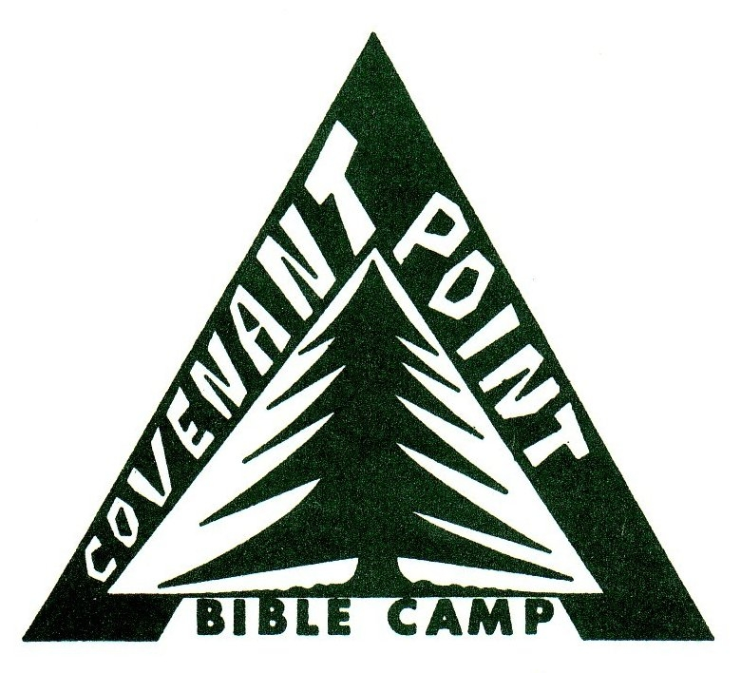
Canoe Trip: Flambeau River
(6/7/8) or (9/10/11/12)

Dear Trip Camper,

We are excited that you have decided to join us on the canoe this summer! Wilderness trips are a unique and exciting way to experience nature, engage with friends and recognize God. Canoeing is a great way to travel through the wilderness and you will soon learn to rely on our group and yourself in new ways. No previous canoeing experience is necessary, although you do need to be willing to paddle a canoe, spend the week outdoors and participate in the challenges and joys of wilderness camping.

As we prepare for our week together, there is some information that you should be aware of. If you have any other questions, please be sure to contact Covenant Point at 906-265-2117 or check out cpbc.com/trips. We look forward to seeing you this summer!

The following is a list of recommended items needed for the trip. Please do not feel the need to purchase a pile of expensive equipment. Many items can be borrowed or found at thrift stores. Tents, 2/3 length “ridge rest” sleeping pads, dry-bags, Duluth packs and cooking equipment will be provided. Your first night at camp we will unpack our bags and repack our gear into the dry-bags that we provide for you, and split up communal gear and sleeping bags amongst Duluth packs. Your luggage, a clean outfit, and unnecessary items (including phones and electronics) will be stored safely at camp for the time we are on the river.

- 1 nylon “mummy style” sleeping bag with stuff sack: must be warm, lightweight and packable (4-5 pounds max, fit into stuff sack 10 x 20 max), 20 degree F rating.
- Water shoes, old tennis shoes that you can wear in the river, or sandals with a back strap
(NO flip-flops or Crocs – these can come off and float downstream)
- 3 t-shirts and 4-5 pair underwear.
- 1 pair tennis shoes or sandals to change into at campsite.
- 2-4 pair warm socks.
- 1 warm fleece or wool long sleeve layer.
- Waterproof rain jacket and pants
- 1 pair of loose fitting pants for campsite (not cotton or jeans)!
- 2-3 pair quick drying shorts
- Something to sleep in
- 1 modest swimsuit
- Sunglasses, brimmed hat, sunscreen, lip balm
- Bug spray
- Headlamp or small flashlight
- Small Bible, journal, pen, camera (packed in Ziploc bag)
- Toiletry items (use small travel containers and pack in Ziploc bag)
- Small towel or camping towel
- Optional fishing pole/tackle: No WI fishing license necessary if under 17
(The Flambeau River is known for smallmouth bass and musky, as well as other species)
- Tampons for women
- One outfit to leave at camp to change into after the trip.
- 6 or 7 Two gallon Ziploc bags (to put clothes in to keep dry)
- Spending money if you wish to purchase snacks during the trip or visit the canteen at camp.

