For Public Safety Parts of the Ge-Che Trail are Temporarily Closed during Logging Operations
Trail sections lined in purple are closed for the 2014-2015 winter season.
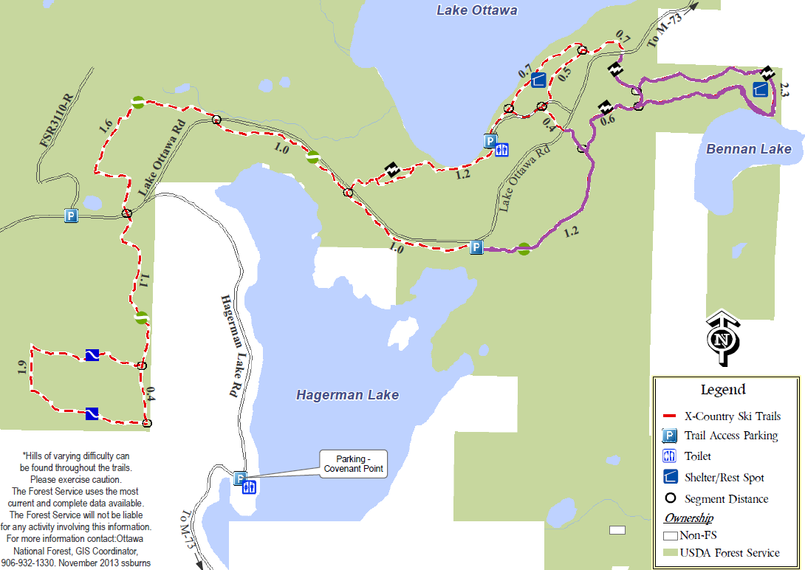

Thank you for your cooperation!
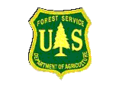
For additional information, contact the Watersmeet/Iron River District Office at 906-358-4551

