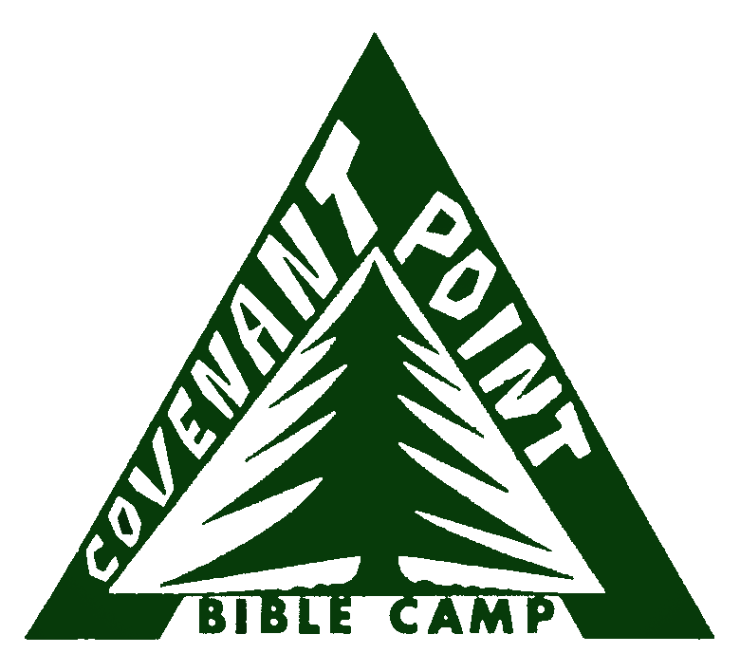**­­­Covenant Point Bible Camp**

358 W. Hagerman Lake Rd.

Iron River, MI 49935

Phone: 906.265.2117 Fax: 906.265.5123

www.cpbc.com, [registrar@cpbc.com](mailto:registrar@cpbc.com)

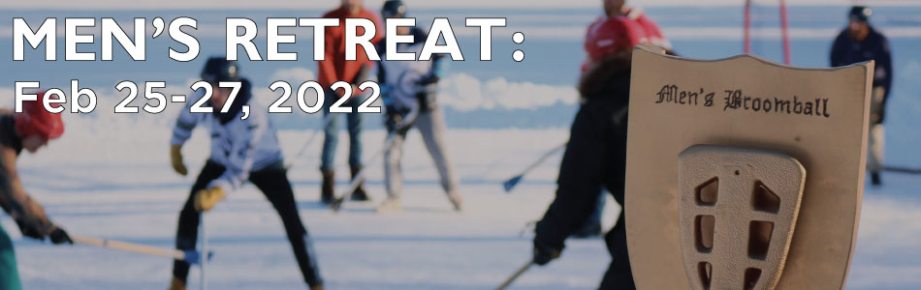

**2022 Men’s Retreat**

7:00 PM Friday, Feb 25 – 10:00 AM Sunday, Feb 27



Come for a weekend of fun, fellowship, meaningful conversation, and worship. The Men’s Retreat is a highlight for many each year at Covenant Point. Invite your friends for the excellent food, good times, and life-giving worship and message. Recreational opportunities include a broomball tournament, afternoon jam session (bring your own instrument), snowshoeing, cross-country skiing on our groomed trails, sauna and polar bear dip, or games and conversation in the dining hall.

Check-in begins at 7:00 PM on Friday, with our first gathering at 8:00 PM.

We’ll be continuing to implement COVID-19 precautions, including limiting the size of this retreat to keep the Dining Hall and Tabernacle less crowded, so registration will be initially limited to 100 participants. Please register early to guarantee your spot at the retreat. Please read our most recent **Retreat COVID-19 protocols at** [www.cpbc.com/retreat-covid-19-protocols](http://www.cpbc.com/retreat-covid-19-protocols)**.**

Packing List

Bedding

Winter clothing

Towel

Toiletries

Swimsuit for sauna (if interested)

Musical instrument for jam session

(if interested)

Bible

Notebook and pen

Flashlight

To Register:

Mail, email, or fax registration and payment to:

Covenant Point Bible Camp

358 W. Hagerman Lake Rd.

Iron River, MI 49935

Fax: 906.265.5123

registrar@cpbc.com

-or-

Register online at:

[www.cpbc.com/mensretreat](http://www.cpbc.com/mensretreat)

Payment Information

* **Full Retreat:**

**$140** ($120 Earlybird*)

Pastor Rate: $70

7PM Friday – 10AM Sunday

* **Saturday Evening Departure:**

**$120** ($100 Earlybird*)

Pastor Rate: $60

7PM Friday – Saturday PM

* **Saturday Only (no lodging):**

**$80** ($70 Earlybird *)

* **Full Retreat, Commuter (no lodging):**

**$100** ($90 Earlybird *)

A $25 processing fee will be kept in the case of any cancellation one week (7 days) or more from the start of the retreat. In the case of a cancellation less than one week from the start of the retreat, no payments will be refunded. Any cancellations related to COVID-19 will be refunded in full.

**\* Early Bird Discount applies if paid and registered or postmarked by 2/11/22**

More details on this year’s speaker & theme at [www.cpbc.com/mensretreat](http://www.cpbc.com/mensretreat)

**2022 Men’s Retreat Registration Form**

7PM Friday, Feb 25 – 10AM Sunday, Feb 27



Covenant Point Bible Camp

358 W. Hagerman Lake Rd.

Iron River, MI 49935

Phone: 906.265.2117 Fax: 906.265.5123

www.cpbc.com, [registrar@cpbc.com](mailto:registrar@cpbc.com)­

We’ll be continuing to implement COVID-19 precautions, including limiting the size of this retreat to keep the Dining Hall and Tabernacle less crowded, so registration will be initially limited to 100 participants. Please register early to guarantee your spot at the retreat. Please read our most recent **Retreat COVID-19 protocols at** [www.cpbc.com/retreat-covid-19-protocols](http://www.cpbc.com/retreat-covid-19-protocols)**.**

*If it becomes apparent that we cannot run a retreat as planned due to COVID-19 considerations, we reserve the right to make changes to capacity, program, or calendar as necessary. Prior to each retreat, we will be in communication with participants regarding instructions and policies to reduce health risks for our participants and staff. Any cancellations related to COVID-19 will be refunded in full.

Last Name: First Name:

Address: City/State/Zip:

Home Phone: Day phone: Cell phone:

Email:

How did you hear about Covenant Point?

Church Name: Church City/State:

Insurance Company: Policy #:

Emergency Contact Name and Phone #:

Arrival & Departure / Payment:

* Early Bird Discount applies if paid and registered or postmarked by 2/11/22

* Full Retreat: $140 ($120 Earlybird)
* Fri Night – Sat Dinner: $120 ($100 Earlybird)
* Sat Only (No Lodging): $80 ($70 Earlybird)
* Full Retreat, Commuter (No Lodging): $100 ($90 Earlybird)
* Pastor Rate, Full Retreat: $70
* Pastor Rate, Saturday Evening Departure: $60

A $25 processing fee will be kept in the case of any cancellation one week (7 days) or more from the start of the retreat. In the case of a cancellation less than one week from the start of the retreat, no payments will be refunded. Any cancellations related to COVID-19 will be refunded in full.

* **Dietary Restrictions:**

Please provide written explanation of dietary restrictions and/or food allergies below including treatment plan in the event of an allergic reaction and permission to share allergy-related information with appropriate staff.

__________________________________________________________________________________________________________________________________________________________________

**COVID-19 Screening:**

Has the participant been vaccinated against COVID-19? Yes / No

Does the participant possess, or has a healthcare provider told the participant that they possess any high-risk factors that should prevent you from participating in programs at Covenant Point?

Yes / No

If yes, please provide written explanation of risk factors.

__________________________________________________________________________________________________________________________________________________________________

**COVID-19 Symptom & Exposure Screening Compliance**

If participant experiences any COVID-19 symptoms in the 10-days leading up to arrival at CPBC, or is exposed to a confirmed or suspected case of COVID-19, I agree to contact Covenant Point at (906) 265-2117 for guidance on how to proceed. I know that a positive case, exposure, or symptoms of COVID-19 may make participant(s) ineligible to come to camp program, or may require testing prior to coming to camp.

Yes / No

**Release and Waiver of Liability**

**& COVID-19 Symptom & Exposure Screening Compliance**

**General Release and Waiver of Liability**

I hereby give my consent to have the above-named Participant fully participate in all camp activities, outings and field trips conducted on and off the campus of Covenant Point recognizing that there are risks known and unknown, foreseeable and unforeseeable involved in participating in these or similar activities. Covenant Point has taken reasonable and prudent steps to reduce known and foreseeable risks. I understand activities may be strenuous and/or outdoors and agree that participation in activities is voluntary. I understand and agree that neither Covenant Point nor its trustees, officers, directors, employees, agents or representatives may be held liable in any way for any injury, harm, damage or death which may occur to the above Participant as a result of participation in these activities and hereby release, save and hold harmless the above mentioned of said injury due to participation in these activities. Further, I do consent to any and all medical treatment that may be deemed necessary for the Participant should he/she require such assistance. I agree that my insurance plan is the primary plan to pay for the medical, dental or hospital care or treatment that is given to the Participant. I agree to allow Covenant Point to transport Participant as needed and to use a photocopy of this form as my authorization when necessary. Covenant Point may use the Participant’s photo, films, digital images, videotapes and sound recordings in future promotional materials. I have read and voluntarily agree to the statements herein.

**COVID-19 Release and Waiver of Liability**

Evidence has shown that COVID-19 can cause serious and potentially life-threatening illness and even death. Covenant Point cannot prevent you or your child(ren) from becoming exposed to, contracting, or spreading COVID-19 while utilizing Covenant Point’s services or premises. It is not possible to prevent against the presence of the disease. Therefore, if you choose to utilize Covenant Point’s services and/or enter onto Covenant Point’s premises you may be exposing yourself and your child(ren) to and/or increasing your risk of contracting or spreading COVID-19.

ASSUMPTION OF RISK: I have read and understood the above warning concerning COVID-19. I hereby choose to accept the risk of contracting COVID-19 for myself and/or my child(ren) in order to utilize Covenant Point’s services and enter Covenant Point’s premises. These services are of such value to me and to my child(ren), that I accept the risk of being exposed to, contracting, and/or spreading COVID-19 in order to utilize Covenant Point’s services and premises in person.

WAIVER OF LAWSUIT/LIABILITY: I hereby forever release and waive my right to bring suit against Covenant Point and its owners, officers, directors, managers, officials, trustees, agents, employees, or other representatives in connection with exposure, infection, and/or spread of COVID-19 related to utilizing Covenant Point’s services and premises. I understand that this waiver means I give up my right to bring any claims, including personal injuries, death, disease or property losses, or any other loss, including but not limited to claims of negligence and give up any claim I may have to seek damages, whether known or unknown, foreseen or unforeseen.

COVID-19 SYMPTOM & EXPOSURE SCREENING: If participant experiences any COVID-19 symptoms in the 10-days leading up to arrival at CPBC, or is exposed to a confirmed or suspected case of COVID-19, I agree to contact Covenant Point at (906) 265-2117 for guidance on how to proceed. I know that a positive case, exposure, or symptoms of COVID-19 may make participant(s) ineligible to come to camp program, or may require testing prior to coming to camp.

Participant Signature /

Legal Guardian (if minor): __________________________________________________________________

Printed Name: ____________________________________________________ Date: __________________